Name _______________________

Points: 100

“What's In Your Head?"
Adobe Illustrator poster project

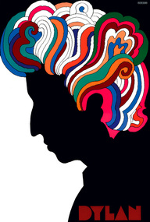

I would suggest sketching out ideas on a sheet of paper prior to design in Illustrator—Get your creative juices going and get your ideas on paper.

Create a new document Standard sheet of paper (you can choose landscape or portrait).
Name the document: WhatsinyourheadLastname

To create these vector self-portrait posters, take a photograph of yourself—a profile picture.

Place it into Adobe Illustrator, then traced your silhouette with the pen tool. Select graphics illustrating your personality and interests were created through a combination of basic shape tools, the pen tool, and dingbat fonts--- Make sure all are VECTOR Images, tracing our outlining the images.

Place Your Name somewhere inside with a font that is also reflective of you!
The above are merely examples…do not mimic Think outside the box…. Do not limit yourself…EVER…

Print to Color Printer
Turn into Handin Folder, make sure it is named : WhatsinyourheadLastname

